University Management System
Databases and Big Databases
Project by:-
Panav Ailawadi
GH1047862

In this project, I created a University Management System database using SQL. The purpose of this system is to store and manage data related to students, courses, and instructors in an organized way.
A university handles a lot of information, so it is important to have a structured database that makes it easy to store, update, and retrieve data when needed.
This system allows:
- Adding and managing student details
- Storing course information
- Assigning instructors to courses
- Enrolling students in courses
- Running queries to get useful information
The project also helped me understand how relational databases work in real-life situations.
The database is designed using different tables, where each table represents a specific part of the system.
Main Tables
- Students – stores student details like name, email, and date of birth
- Courses – stores course names and credits
- Instructors – stores instructor details and department
- Enrollments – connects students and courses
- Course_Instructor – connects courses and instructors
Relationships
- One student can take many courses
- One course can have many students
- One instructor can teach multiple courses
To manage these relationships, I used:
- Enrollments table for student-course relationship
- Course_Instructor table for course-instructor relationship
Normalization
The database is properly organized to avoid repeating data. Each table stores only the necessary information, which makes the system clean and efficient.
Database and Tables
First, I created the database and then added all the required tables. Each table has a primary key to uniquely identify records.
I also used foreign keys to connect tables and maintain relationships between them.
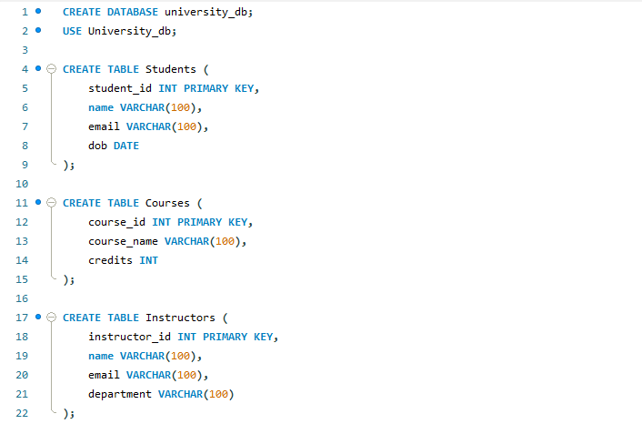
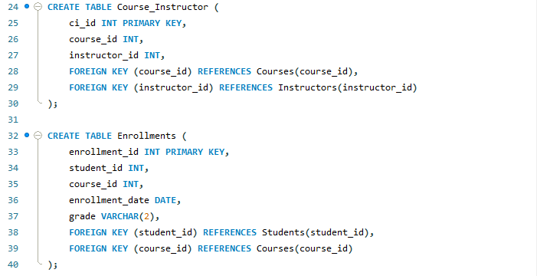

Data Insertion
After creating the tables, I added sample data such as:
- Students (Rahul, Aman, Sara, etc.)
- Courses (Database Systems, Mathematics, Computer Networks)
- Instructors (Dr. Smith, Dr. John)
This helps in testing the database and running queries.
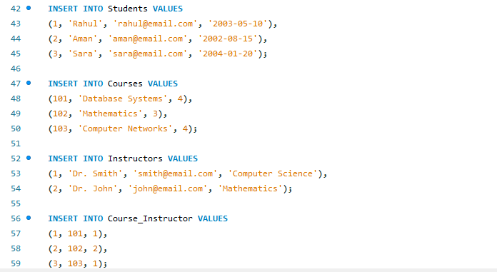
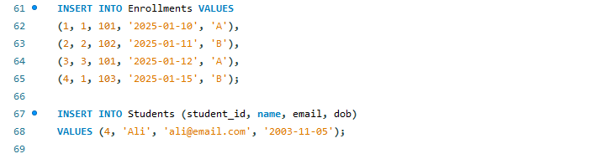

Basic Operations (CRUD)
I performed all basic database operations:
- Insert – to add new data
- Select – to view data
- Update – to change existing data
- Delete – to remove data
Example:
- Updated a student’s email
- Deleted a student record

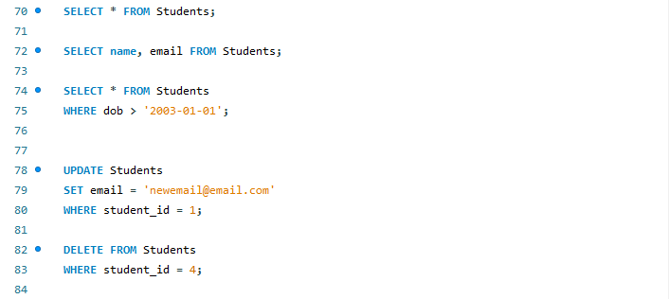

Queries and Functionality
I used different SQL queries to show how the system works.
1. Join Query (Student and Course)
This query shows which student is enrolled in which course.
2. Course and Instructor Query
This shows which instructor teaches each course.
3. Aggregation Query
I counted how many students are enrolled in each course.
4. Average Calculation
I calculated the average credits of all courses.
5. Sorting Data
I sorted students alphabetically by name.
These queries show that the database can handle real-world tasks.
The database works correctly and produces the expected results.
It can:
- Store and organize data properly
- Show relationships between tables
- Perform calculations like averages and counts
- Display useful information using queries
For example:
- We can see which students are in which courses
- We can find how many students are in each course
- We can check which instructor teaches a course

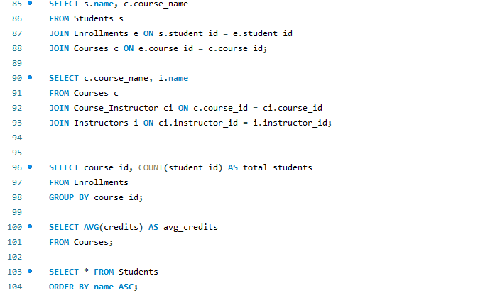

Challenge 1: Managing Relationships
At first, it was confusing to connect students, courses, and instructors.
Solution:
I used separate tables (Enrollments and Course_Instructor) to handle these relationships.

Challenge 2: Writing Join Queries
Join queries were a bit difficult to understand in the beginning.
Solution:
I practiced using table aliases and step-by-step joins to make it easier.

Challenge 3: Data Consistency
There was a risk of incorrect or missing data.
Solution:
I used primary keys and foreign keys to keep the data accurate.

Conclusion and Future Work
Conclusion
This project helped me understand how to design and build a relational database system. I learned how to create tables, connect them, and write queries to manage data.
The system works well for managing university data and shows how databases are used in real life.

Future Improvements
In the future, this system can be improved by:
- Adding more features like attendance and timetable
- Using indexes to improve performance
- Creating a user interface (frontend)
- Adding more complex queries

